**Tai Chi Fit  
 Exercise Class**

Tai Chi is a gentle exercise that improves balance and reduces falls. Perfect for seniors, those with limited mobility, or anyone looking for some seated exercise.

Join us at the

**Waveland Library   
 Thursdays 10:00am – 11:00am**

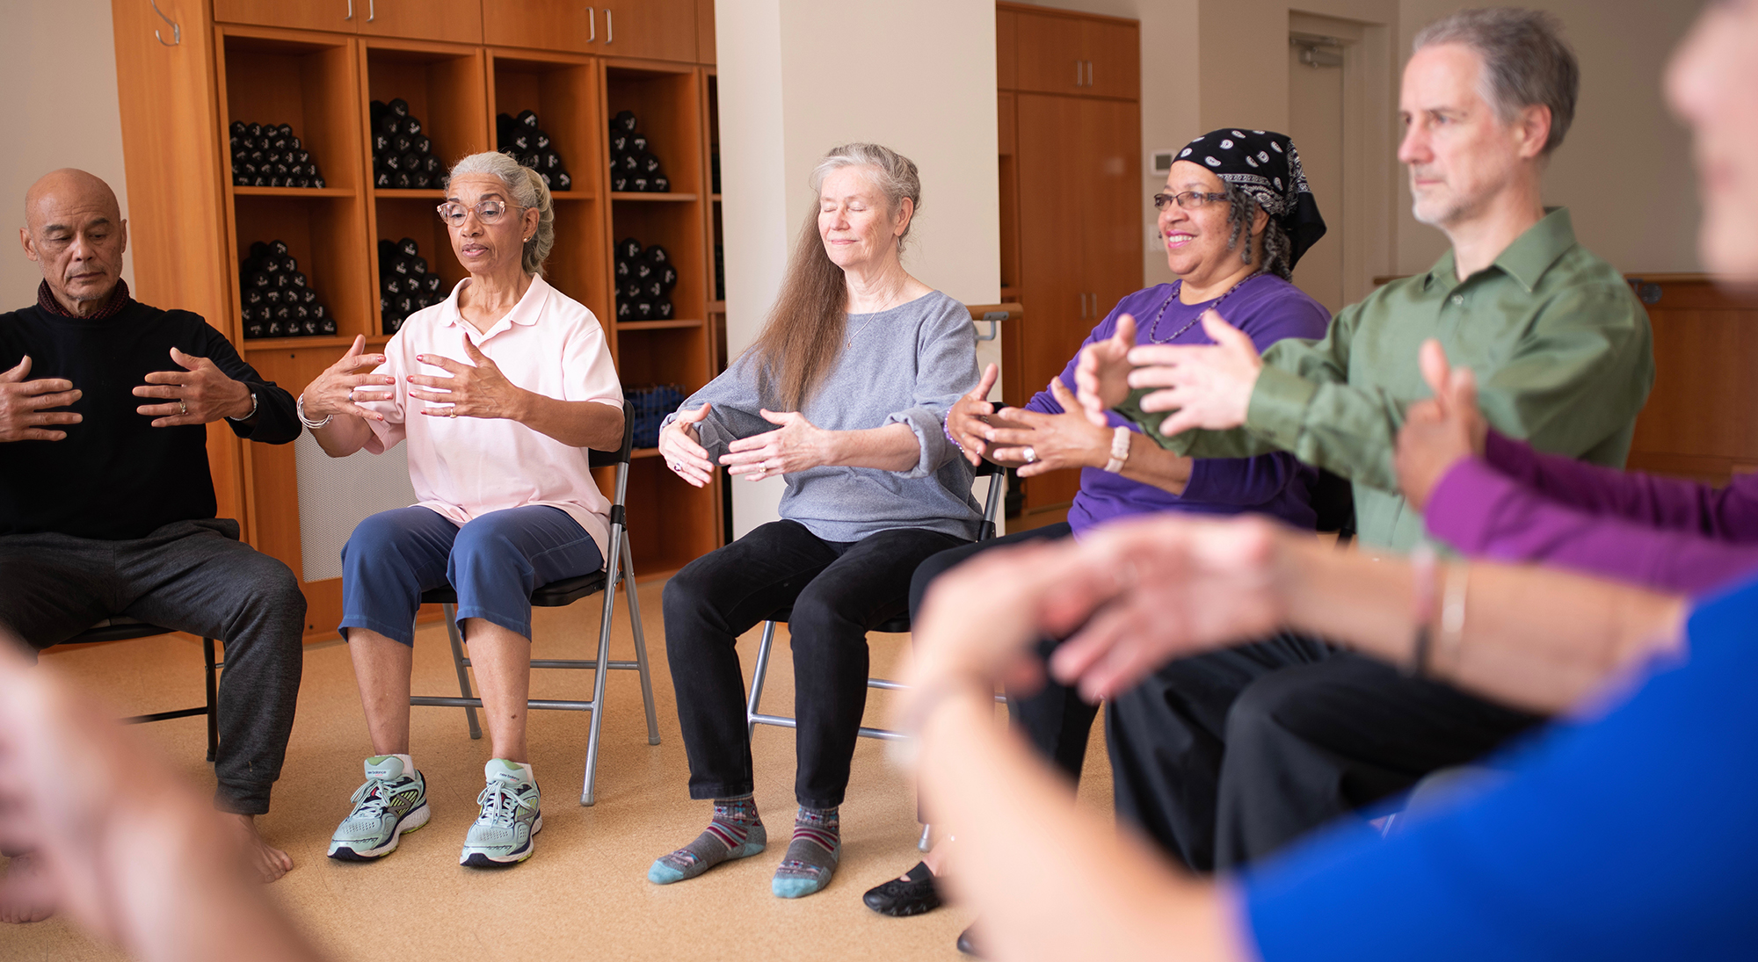

**Tai Chi Fit  
 Exercise Class**

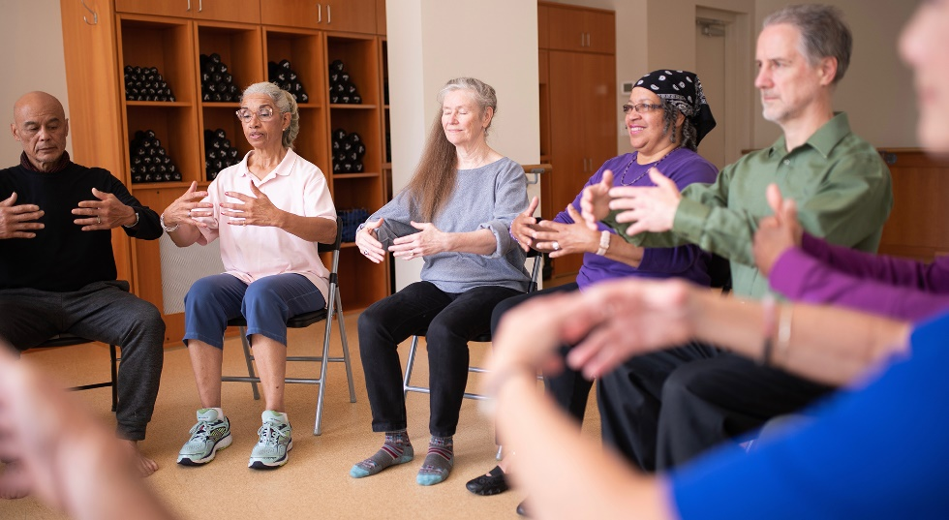

Tai Chi is a gentle exercise that improves balance and reduces falls. Perfect for seniors, those with limited mobility, or anyone looking for some seated exercise.

Join us at the

**Waveland Library   
 Thursdays 10:00am – 11:00am**