***NEW LIBRARY PROGRAM!***

***“TRUE CRIME TUESDAYS!”***

**with EH Library Manager, Leah Holmes, Ph.D. (abd)**

**Tuesday, Jan. 14, 10-11 AM**

**The Radium Girls**

***Please see library staff to register; must have 5 for class to make.***

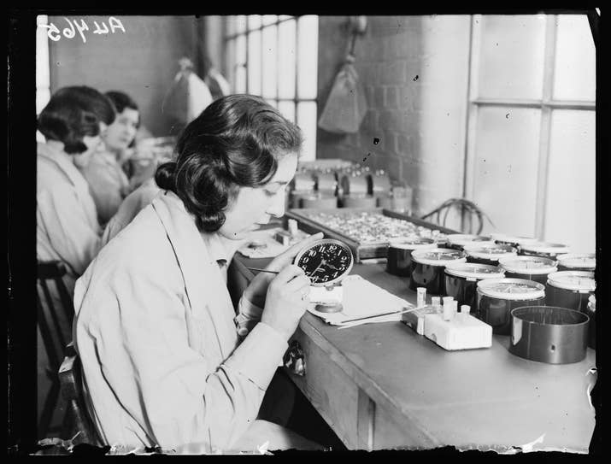

Photo Credit: Wikimedia Commons

**Overview of the Case:**

When Marie and Pierre Curie discovered ***radium*** in 1898, manufacturers quickly adopted the chemical element into their processes: clock faces, watches, and instrument panels were all coated with the stuff to provide “glow in the dark” properties. But soon, factory workers discovered that this exciting new “paint” brought with it some horrible side effects.

As a radioactive element, radium is highly toxic to humans, particularly when ingested or inhaled. While it seemed unlikely that anyone would ingest or inhale the radium used to paint a clockface, this fact posed a serious problem for the largely female factory workers whose job it was to paint the dials. These “Radium Girls,” as they would come to be known, not only spent most of their day in close proximity to the paint, but also employed a technique in which they frequently wet their paintbrushes with their mouths, consuming small amounts of radium in the process. Yep, you can imagine where this is going….

Join us as we explore this fascinating case. Though the court battle would ultimately yield a major victory for the American labor movement, it was a battle hard-won and of little comfort to the “Radium Girls.”

*---With credit to the Morbid podcast.*

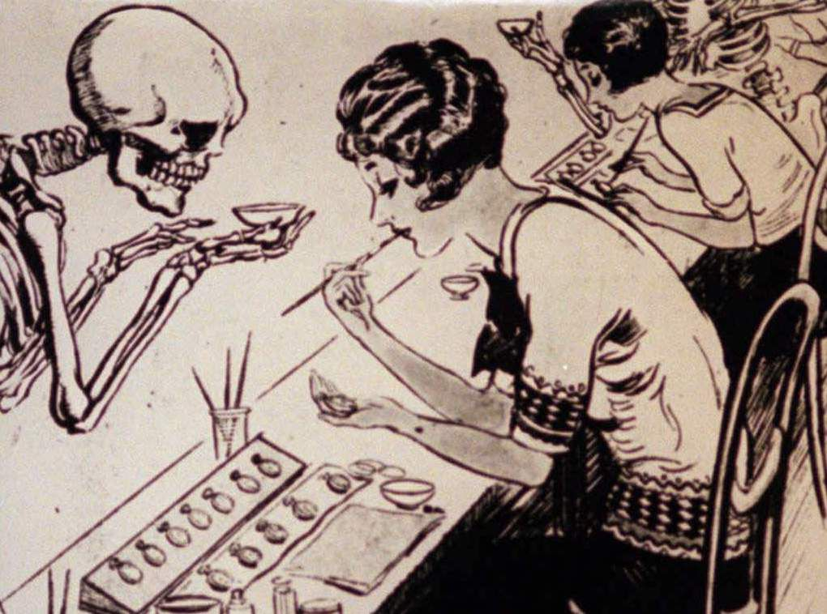

A copy of a Radium Girls cartoon published circa 1922-1923 in which skeletons hover around workers who put brushes covered in toxic paint in their mouths. *Star-Ledger file photo*

***About the presenter:*** *Leah Holmes holds advanced degrees in literature and English. A retired high school teacher and USM English Instructor, she's now intrigued by—and enjoys sharing with others—strange and thought-provoking true crime stories. She managers the East Hancock Library Branch and hosts True Crime Tuesdays!,* ***which meets from 10 -11 AM on the 2nd Tuesday of each month.***

***\*\*Please register at front desk or call 255-4800 to register. Must have 5 for class to make.\*\****