***Where is Brandon?***

**PART 2**

***A “True Crime Tuesdays” Presentation***

***From Leah Holmes, Ph.D. (ABD)***

**Tuesday, March 11, from 10-11**

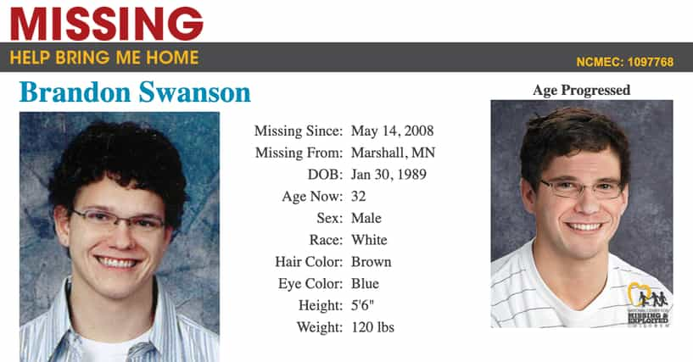

**In 2008, on a dark Montana road in the middle of the night, Brandon S. called his parents reporting car trouble and asking if they could they come get him.  His parents left at once to help their son.**

***They never found him.*  
  
 In Part 1 of the presentation, we covered the baffling, bizarre, and as-yet unsolved true crime mystery of Brandon—a 19-yr-old college student who went missing only miles from his home.  Using information gleaned from investigators, search dogs, cell phone towers, and Brandon's parents, we’ll trace Brandon's last known movements and odd utterances the night of his disappearance.**

**In Part 2 of the presentation, we’ll review the strongest theories of what might have happened to Brandon, with *one theory in particular* topping all the others—a theory as shocking and disturbing as it is sorrowful.**

**Hope to see you for PART 2 as we try to answer the question, *where is Brandon?***

***Please note that this True Crime "missing person" presentation is intended for adults; its content is not suitable for children.***

***About the presenter:******Leah Holmes holds advanced degrees in literature and English.  A retired high school teacher and USM English Instructor, she's now intrigued by--and enjoys sharing with others--strange and thought-provoking true crime stories. She manages the East Hancock Library Branch and the host of True Crime Tuesdays, which meets from 10-11AM on the second Tuesday of each month.***